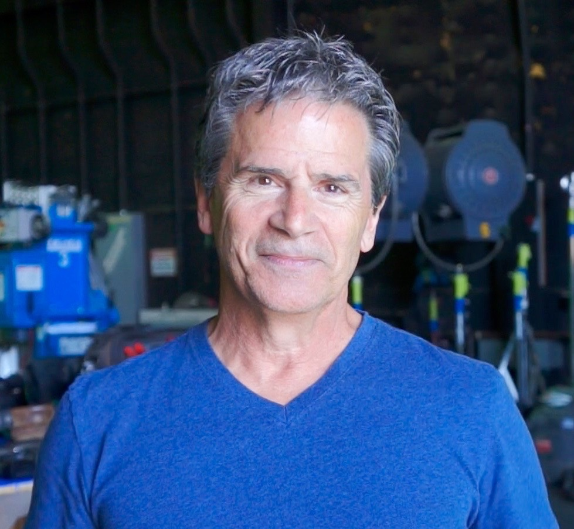

**ROCKY CAPELLA**

**SAG-AFTRA-DGA**

### Direct Lines : 650 678-8173

### Website: [www.rockycapella.com](http://www.rockycapella.com) or check IMDB

***Over 600 projects as an actor, stunt coordinator, performer and/or 2nd unit director:***

***\*Partial list of projects with acting roles below: **more than a stunt related character & dialogue***

**FEATURE FILMS & TV (Partial List) Position Director/Company**

Venom 2 Featured (Valet) *Andy Serkis/*Columbia Pictures

Guitar Man – Co-Starring** (Keaton’s Parole Officer) *Rocky Capella*/Prodigy Ent.

Mr. Invincible Featured (drunk party patron) *Vijay Rajan*/Cinequest Studios

Chasing Mavericks Featured (Bus Driver) *Michael Apted*/Curtis Hansen Dirs.

Red Tails Featured Soldier (Half track Corporal) *George Lucas*/Lucasfilm

Inferno Co-Starring (Kylie’s Dad) *Dusty Nelson*/Porchlight Ent.

Ed TV Featured (**Russian Immigrant) *Ron Howard*/Imagine-Universal

Milk Money Featured (teacher) *Richard Benjamin*/Paramount

Jack Featured **(drunk Patron) *Francis Ford Coppola* (Disney)

High Crimes Featured (Cop) *Carl Franklin*/Columbia

Fist Of The Northstar Featured (survivalist) *Tony Randell*/Overseas films

*Continued…*

**TELEVISION – SERIES, PILOTS AND CABLE PROGRAMS *(partial List)***

Nash Bridges 2021 Featured Greg Beeman/N Village prods.

13 Reason’s Why Co-Starring – **recurring role (Boxing Referee)

episode 405 *Brenda Strong*/Parmount/Netflix

episode 408 *Sunu Gonera*/Paramount/Netflix

Fast & Loud (Bullitt Recreation) Featured (interviewed & Narrator) Discovery Channel

Raven’s House (pilot) Featured (**Gym Teacher) *Eric Dean Seaten/*Disney

Walk The Prank – Ep. #203 Featured (crazed driver) *Tom Gianas/*Horizon Pictures TV

CHANCE – Pilot Featured (**Angry Mercedes Owner) *Lenny Abrahamson/*Fox-Hulu

- Episode 103 Featured (Cab driver) *Michael Lehmann*

- Episdoe 107 Featured **(flashback ‘80’s drunk driver) *Michael Lehmann*

SENSE8 – series (Ep. #203) Featured – (**Metzer’s Neighbor ) *Wachowski’s/*Netflix

Company Town Co-Starring – Jack *Thomas Carter*

So, You want to Be Stuntman? **Lead and Narrator Jury Productions (series pitch)

Traffic – Pilot **Featured (**Boxing coach) *Mick Jackson*/High Prods.

Escapes Routes Stunt-Safety (**Narrator) NBC/Shannon McGinn

Jesse Hawkes Featured – (**Drug Dealer) Robert Conrad

MythBusters & Prototype This (**Narrator for sequences) Beyond Productions

*Continued…*

**NEW MEDIA AND OTHER PROJECTS: *(partial List)***

Bill Viola Video Art Projects series: Featured Actor on: “The Raft”, “Desert”, “Resurection”, and “Deluge”

EA Boxing: **Boxing Coach and Referee EA Sports

Totally Hidden Video – **featured player – Sean McNamara/ABC TV

Candid Camera – **Featured player Peter Funt Jr.

Must We Fall – **Starring role and narrator – Visucom Production

*Continued…*

**COMMERCIALS:  *(partial list)***

- HOIST Ride Sharing PSA Lead** - Director/RCP FIILMS

- Regressive Insurance Lead/Announcer** - RCP Films (Spec)

*-* Subaru – Boxing Coach and referee - Nick Lewin/Crossroads films

- Microsoft airport Airline pilot Stacy Wall/Imperal woodpecker

- AMX “ice cream truck” Thief Chris Palmer/Olgilvy & Mather

- Bell Atlantic James Earl Jones Limo driver Michel Apted/Redback Films

- Travelers Insurance “Risk” Customer Lance Accord/Park Pictures

- ESPN Promo Athlete ESPN Films

- Travelers Insurance “Snowball” Pedestrian Danta Ariola/MJZ

- NCAA “Blitz” Athlete G. Guiterrez/Colossal Pictures

***See IMDB or my website for Reels, complete resume and more information***